# Recursive Function Assignment

1. WAP to calculate the maximum stack depth of a recursive call to a function. (For eg a factorial function ).

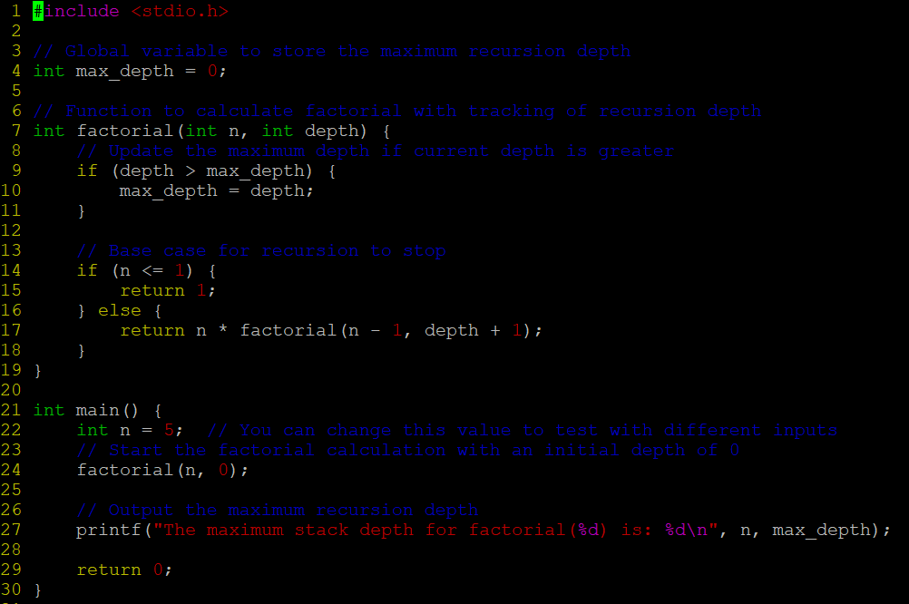



1. What is tail recursion? Why is it important? Give an example

**Tail recursion** is a special form of recursion where the recursive call is the last operation in the function. This means that the function performs all its computations before making the recursive call, and there is no need to retain the current function's stack frame after the recursive call.

**Importance of Tail Recursion:**

1. **Prevents Stack Overflow**: Without tail recursion, each recursive call consumes stack space, which can lead to a stack overflow if the recursion depth is too large. Tail recursion prevents this by allowing the function call stack to be reused for each new call.
2. **Increased Efficiency**: Tail-recursive functions, when optimized, can run with constant stack space, making them more efficient for large input sizes.

